**One Click Automation!!**

**🔷In just "ONE CLICK" we will get a cluster, ❗READY TO USE❗**

**📢 Repeat, CLUSTER READY TO USE📢**

**❗END TO END AUTOMATION ❗**

**🔷Infrastructure:**

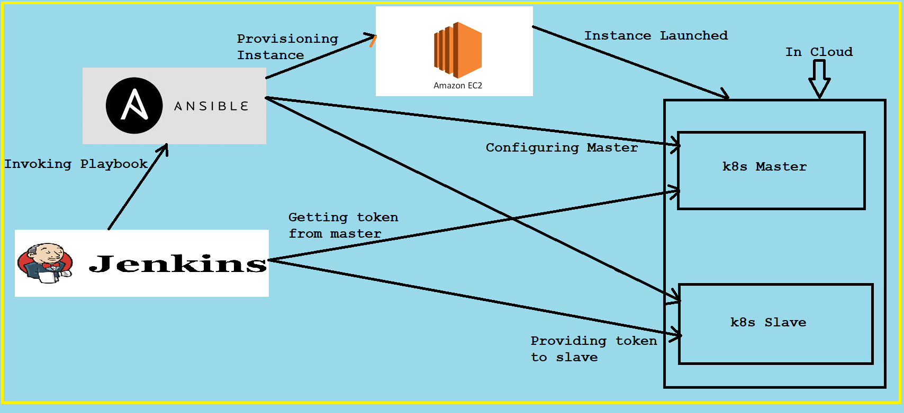

**🔷Technologies used:-  
 - Ansible(Dynamic Inventory)  
 - Jenkins(Pipeline as Code)  
 - AWS(EC2)  
 - k8s  
 - Shell Scripting**

**🔷Abstract:-**

* **Jenkins pipeline plays major role in connecting & integrating the different technologies. To be precise I used pipeline as code.**
* **Jenkins pipeline is the one which invokes Ansible playbook, then ansible provision the instance over AWS & also it is the one which configure them.**
* **Jenkins is used for connecting master and slaves.**
* **Basically Jenkins generates token from master & provides it to the slave!!!**

**🔷Hence in just "ONE CLICK" we will get a cluster, ❗READY TO USE❗**

**🔷 I have created a demo video & posted on my LinkedIn Account. Do LIKE(👍), comment(💬) & share your valuable feedback(🙏)**

**Link for video is in description!!!**

